Pancake Sorting 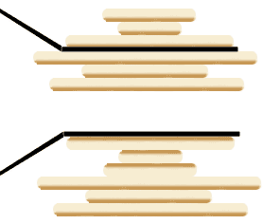

**When it was developed**

Originally Proposed by **Jacob E. Goodman** in **1975** but expanded upon by **Bill Gates** in **1979**

**Running time(s)**

The overall time complexity is O(n^2).

**Overview of how it works (pseudocode or few English sentences)**

This algorithm focuses on reversing the order or “flipping” a segment of the entire data set so each time it iterates through, the unsorted “pancake stack” is reduced by one. The element with the highest value of the data still being flipped and put above the next highest value (which is already sorted). This problem was originally asked to determine a “pancake number” which was the minimum number of flips needed to sort pancakes by size.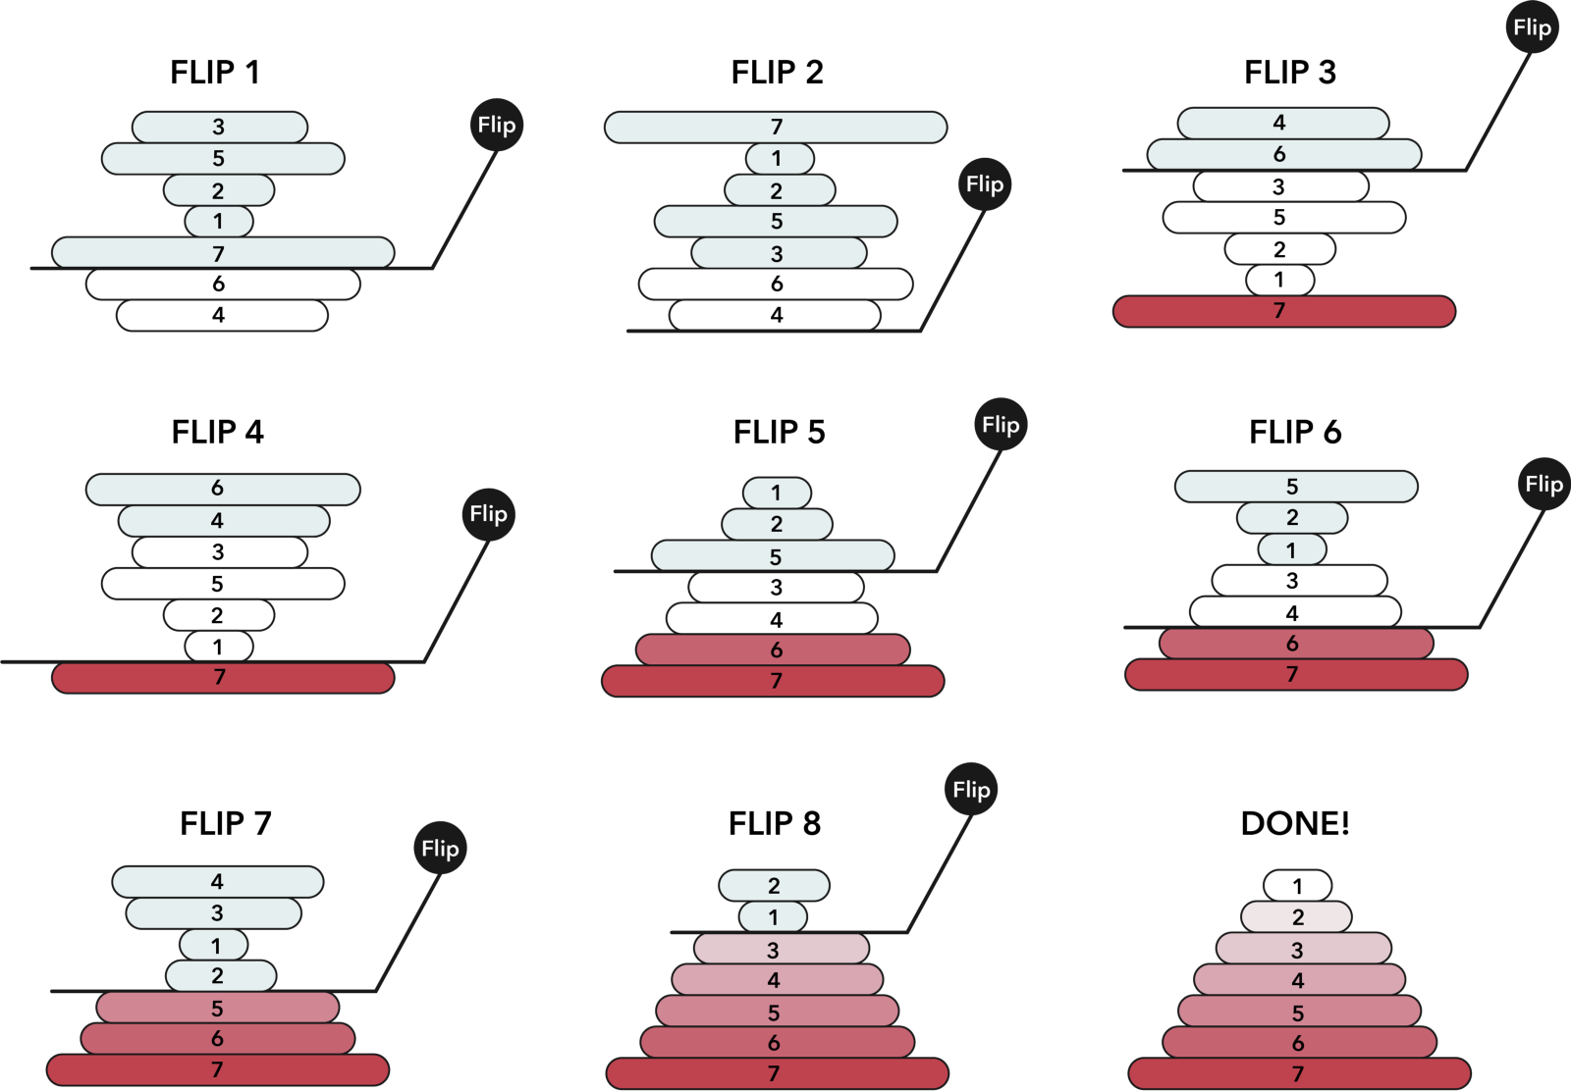

**Strengths**

Pancake graphs can exhibit symmetric and recursive structures as well as small degrees and diameters relative to the size of the graph. These qualities make it a good algorithm for parallel processing.

**Weaknesses**

Slow run time and unless if close to being in order it has to iterate through a lot of the data. Sorting by reversals is also not as efficient as more exact sorting algorithms that look to sort efficiently.